 

A Minor Project Report On

## UNVEILING FINANCIAL INSIGHTS: LEVERAGING ADVANCED DATA ANALYSIS

Under the guidance of

## Ms. SRIMATHI V

## CORPORATE TRAINER-IBM

**Submitted by**

## SUKANT.R - 927621BAD114

## SUJITH KUMAR.P - 927621BAD113

## SUDHAN KUMAR. - 927621BAD112

## DEPARTMENT OF

**ARTIFICIAL INTELLIGENCE AND DATA SCIENCE**

## M.KUMARASAMY COLLEGE OF ENGINEERING

(Autonomous) KARUR – 639113

## TABLE OF CONTENTS

|  |  |  |
| --- | --- | --- |
| **CHAPTERNO** | **TITLE** | **PAGENO** |
| **1** | **INTRODUCTION**   * 1. Problem Statement   2. Objective | **03**  **04**  **04** |
| **2** | **EXISTING & PROPOSED SYSTEM**   * 1. Existing System   2. Proposed System | **06**  **07**  **09** |
| **3** | **METHODOLOGY** | **11** |
|  | **3.1Unveiling financial insights: leveraging advanced data analysis** | **12** |
| **4** | **RESULT & ANALYSIS** | **16** |
| **5** | **CONCLUSION** | **19** |
| **6** | **REFERENCES** | **21** |

CHAPTER-1

# INTRODUCTION

## INTRODUCTION

**PROBLEM STATEMENT:**

## Develop a data analysis and visualization solution for historical stock price data retrieval, analysis, and visualization. The solution should efficiently fetch historical stock price data of specific Stock or ETFs using the y-finance library, process the data to calculate daily returns, and generate insightful visualizations including a time series plot of closing prices and a histogram depicting the distribution of daily returns.

## OBJECTIVES:

Fetch historical stock data for a specified stock symbol from Yahoo Finance within a user-defined date range.

Visualize the retrieved data to analyze the following aspects: Plot the closing prices of the stock over time to observe trends and patterns. Examine the distribution of daily returns to understand the volatility and risk associated with the stock. Allow users to select a preferred theme for the visualizations to enhance readability and aesthetics. Provide a modular and interactive interface where users can input the stock symbol, start date, end date, and preferred theme. Enable users to gain insights into the historical performance and behavior of the selected stock for informed investment decisions or analysis.

**Empathize**: I understand that working with financial data and creating visualizations can be challenging, especially when dealing with intricate details like setting themes and handling user inputs. It's easy to encounter errors or feel overwhelmed by the technical aspects of coding and data analysis. Your effort to create a script that not only downloads stock data but also customizes the visualization to your preferences shows your dedication and attention to detail. By refining the code and ensuring it runs smoothly, you can more effectively communicate insights from the data. Remember, each challenge you overcome is a step forward in mastering these skills, and it's perfectly normal to seek assistance and improve your work iteratively. Keep pushing through, and soon you'll find that these tasks become more intuitive and rewarding.

**Define:**

This content provides encouragement and perspective on the challenges of working with financial data and creating visualizations. It acknowledges the complexity of tasks such as setting themes and handling user inputs in coding and data analysis. The content highlights the user's dedication and attention to detail in refining their script to download stock data and customize visualizations according to preferences. It reassures that overcoming these challenges is part of mastering the skills, normalizes seeking assistance, and emphasizes that iterative improvement leads to better intuition and reward in performing such tasks

**Ideate**: During the ideation stage of enhancing the stock market analysis program, several key areas present opportunities for improvement and innovation. Enhancing visualization and interactivity through tools like Plotly or Bokeh could allow for interactive charts that enable users to zoom in on specific time periods, explore detailed data points, and compare AAPL's performance with industry peers or market indices. Advanced analytics could be integrated by adding technical indicators such as moving averages and MACD, providing deeper insights into stock trends and signals. Machine learning models could be leveraged for predictive analytics, forecasting future stock prices or classifying market trends, while sentiment analysis of news and social media data could offer insights into market sentiment. Real-time data integration would enable the program to analyze streaming data for timely decision-making, reacting to market news and economic indicators effectively. Optimizing portfolios based on risk-return profiles and offering customizable dashboards or a mobile-friendly interface would enhance user experience and accessibility. Ensuring robust data security and compliance with regulations remains crucial to protect sensitive financial information. This approach aims to create a comprehensive and dynamic tool for financial analysis, empowering users with actionable insights in navigating the complexities of the stock market.

CHAPTER-2

# EXISTING & PROPOSED SYSTEM

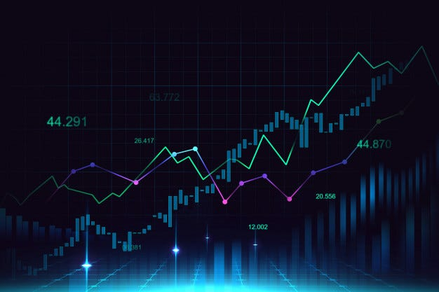

## EXISTING SYSTEM:

The existing systems for analyzing stock market data often incorporate various technologies and methodologies to provide comprehensive insights into stock performance and market trends. Here’s an overview of key components typically found in existing systems:

**1. Data Sources:**

* **Financial APIs:** Many existing systems use APIs (Application Programming Interfaces) provided by financial data providers such as Bloomberg, Yahoo Finance, Alpha Vantage, etc., to fetch real-time and historical stock market data.

**2. Data Processing:**

* **Normalization and Cleaning:** Raw data obtained from APIs are normalized and cleaned to handle missing values, adjust for stock splits, and ensure data consistency.
* **Feature Engineering:** Calculating additional metrics such as moving averages, volatility measures (e.g., standard deviation of returns), and technical indicators (e.g., Relative Strength Index, MACD) to enhance analysis.

**3. Analytics and Visualization:**

* **Statistical Analysis:** Conducting statistical analyses to identify trends, correlations, and anomalies in stock prices and returns.
* **Visualization Tools:** Utilizing visualization libraries (e.g., Matplotlib, Seaborn, Plotly) to create interactive charts, graphs, and heatmaps for better understanding and presentation of data.

**4. Machine Learning and Predictive Modeling:**

* **Predictive Algorithms:** Implementing machine learning algorithms (e.g., regression models, time series forecasting models) to predict future stock prices or classify market movements.
* **Sentiment Analysis:** Integrating sentiment analysis of news articles, social media feeds, and analyst reports to gauge market sentiment and its impact on stock prices.

**5. User Interface and Accessibility:**

* **Web and Mobile Platforms:** Providing user-friendly interfaces accessible via web browsers or mobile apps to allow users to monitor stocks, customize dashboards, and receive alerts.
* **Personalization:** Allowing users to personalize their experience by selecting favorite stocks, setting alerts, and customizing display preferences.

**6. Security and Compliance:**

* **Data Security:** Ensuring data security and compliance with regulations (e.g., GDPR, SEC regulations) when handling sensitive financial data.
* **Audit Trails:** Maintaining audit trails of user actions and data accesses for transparency and regulatory purposes.

**Example Systems:**

* **Bloomberg Terminal:** A widely used professional platform providing financial market data, news, analytics, and trading capabilities.
* **Yahoo Finance:** A popular free platform offering historical data, real-time quotes, and news for stocks, bonds, commodities, and other financial instruments.
* **TradingView:** A web-based platform for traders and investors offering charts, screening tools, and social networking features.

**Benefits of Existing Systems:**

* **Comprehensive Data Coverage:** Access to a wide range of financial instruments and global markets.
* **Advanced Analytics:** Integration of advanced analytical tools and predictive models.
* **Real-Time Updates:** Timely updates on market movements and news affecting stocks.
* **User-Driven Insights:** Empowering users with customizable tools and personalized insights.

## PROPOSED SYSTEM:

This the proposed system based on our ideology:

The proposed system is designed to facilitate the analysis and visualization of historical stock price data. The system leverages Python's powerful data analysis and visualization libraries to provide users with a comprehensive tool for studying stock performance. Here is an overview of the proposed system:

System Components

1. User Input Interface:
   * Stock Ticker Input: Allows users to input the stock ticker symbol they wish to analyze.
   * Date Range Input: Allows users to specify the start and end dates for the historical data analysis.
   * Theme Selection: Provides a selection of visual themes to customize the appearance of the charts.
2. Data Acquisition:
   * yFinance Integration: Downloads historical stock price data from Yahoo Finance for the specified date range.
3. Data Processing:
   * Data Cleaning: Renames columns for clarity and calculates daily returns.
4. Visualization:
   * Closing Price Plot: Visualizes the adjusted closing prices over the specified date range.
   * Return Distribution Plot: Visualizes the distribution of daily returns.
5. **Tools and Libraries:**

**Pandas:** For data manipulation and analysis.

**NumPy:** For numerical computations.

**Matplotlib:** For creating static, animated, and interactive visualizations.

**Seaborn:** For making statistical graphics.

**yFinance:** For downloading historical market data from Yahoo Finance.

1. **Benefits of the Proposed System**

**User-Friendly Interface:** The system provides an easy-to-use interface for inputting stock data parameters and selecting visualization themes.

**Automated Data Retrieval**: The integration with Yahoo Finance simplifies data acquisition, making it quick and efficient.

**Customizable Visualization**s: The ability to choose different themes allows users to tailor the visual output to their preferences or presentation needs.

**Comprehensive Analysis:** By plotting both the closing prices and return distributions, users can gain insights into both the performance and volatility of the stock

**CHAPTER-3**

# METHODOLOGY

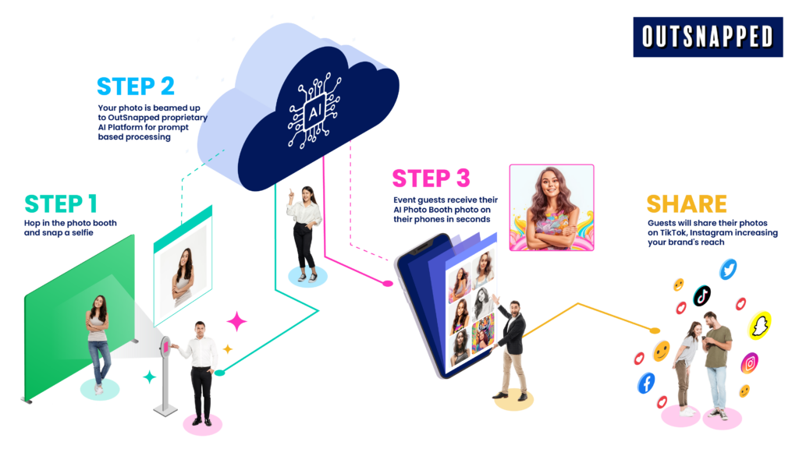

## 3.1UNVEILING FINANCIAL INSIGHTS: LEVERAGING ADVANCED DATA ANALYSIS

**1. User Input:**

**Validation:** Implement input validation to ensure that the user enters valid stock ticker symbols and properly formatted dates.

**Error Handling:** Handle edge cases gracefully, such as handling incorrect inputs or providing defaults in case of missing inputs.

**Feedback:** Provide clear prompts and messages to guide the user through the input process, reducing confusion and errors.

**2. Theme Selection:**

**Preview:** Offer a preview of each theme's appearance to help users make informed choices.

**Customization:** Allow users to further customize plot aesthetics, such as line styles, marker shapes, or font sizes.

**Persistence:** Provide an option to save the selected theme preference for future analyses, enhancing user experience and efficiency.

**3. Data Retrieval:**

**Error Handling:** Handle potential errors during data retrieval, such as network connectivity issues or server timeouts.

**Data Source Options:** Consider offering flexibility in data sources beyond Yahoo Finance, enabling users to fetch data from alternative sources or APIs.

**Caching:** Implement caching mechanisms to improve performance by storing previously fetched data locally and reducing redundant API calls.

**4. Data Preparation:**

**Feature Engineering:** Explore additional features beyond daily returns, such as moving averages, volatility measures, or technical indicators, to enrich the analysis.

**Normalization:** Normalize or scale the data if analyzing multiple stocks with different price ranges to facilitate comparison.

**Handling Missing Data:** Implement strategies for handling missing or incomplete data, such as interpolation, imputation, or excluding affected periods.

**5. Data Visualization:**

**Interactivity:** Add interactive elements to plots, such as tooltips or zoom functionality, to enhance user engagement and exploration.

**Comparative Analysis:** Enable users to overlay multiple stocks on the same plot for comparative analysis, facilitating performance comparison.

**Export Options:** Provide options to export plots in various formats (e.g., PNG, PDF) for inclusion in reports or presentations.

**6. Presentation and Analysis:**

**Automated Insights:** Integrate automated analysis and summary generation to provide key insights, such as trend detection, volatility assessment, or outlier identification.

**Scenario Analysis:** Incorporate functionality for scenario analysis, allowing users to simulate different investment strategies or market conditions and evaluate their impact on returns.

**Interactive Reports:** Generate interactive HTML or dashboard-style reports with embedded plots and dynamic content for more immersive analysis experiences.

**7. Flexibility and Scalability:**

**Parameterization:** Parameterize analysis settings to allow for flexible customization, such as specifying aggregation periods, bin widths, or performance metrics.

**Modularization:** Modularize the codebase into reusable components or functions to facilitate code maintenance, extension, and reuse across different projects.

**API Integration:** Integrate with third-party APIs or libraries for additional functionalities, such as sentiment analysis, news aggregation, or fundamental data retrieval.

**8. Error Handling:**

**Logging:** Implement logging functionality to record errors, warnings, and informational messages for debugging and troubleshooting purposes.

**User Guidance:** Provide informative error messages with actionable guidance to assist users in resolving issues independently or seeking further assistance.

**Fallback Mechanisms:** Design fallback mechanisms or alternative workflows in case of critical errors or unexpected failures to ensure uninterrupted user experience.

**9. Educational Value:**

**Documentation:** Include comprehensive documentation, tutorials, or guides to help users understand the codebase, underlying concepts, and best practices.

**Interactive Examples:** Offer interactive examples or exercises to encourage hands-on learning and experimentation with different analysis techniques.

**Community Engagement:** Foster a community around the codebase through forums, discussion groups, or collaborative platforms to facilitate knowledge sharing and peer support among users.

By incorporating these additional points, the codebase can be further enhanced to provide a richer, more robust, and user-friendly experience for stock market analysis and financial decision-making.

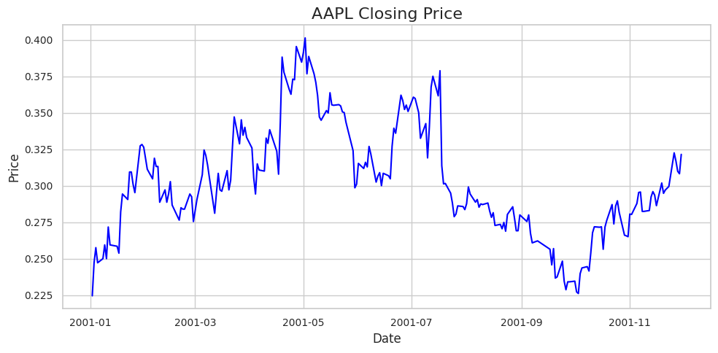

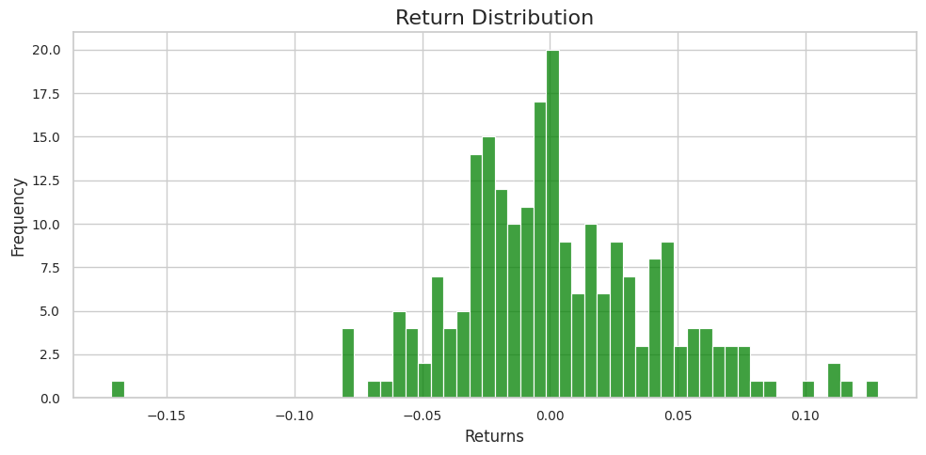

CHAPTER-4

# RESULT & ANALYSIS

**RESULT & ANALYSIS**

Adjusted Closing Price Plot: This plot shows the trend of the stock's adjusted closing price over the specified period. It helps visualize the overall performance and volatility of the stock. The selected style and color enhance the visual appeal according to the user's preference.

Return Distribution Histogram: This histogram displays the frequency distribution of daily returns.

It helps in understanding the volatility and risk associated with the stock. The shape of the distribution can indicate if the returns are normally distributed, have fat tails, or are skewed..

## AI Photo Booth System with Traditional Attire:

The AI photo booth system with traditional attire has the potential to create an engaging and inclusive experience for users. By allowing individuals to virtually try on traditional attires from different cultures, this system can promote cultural diversity, appreciation, and understanding. Users can capture photos of themselves in traditional attire, which can be shared on social media or printed as physical copies. This system aims to provide entertainment while celebrating cultural heritage and fostering a sense of cultural inclusivity.

## Potential Benefits:

**Historical Stock Data Analysis :**

**Trend Analysis**: The line plot of adjusted closing prices over time allows users to observe historical trends in stock prices, which is crucial for making informed investment decisions.

**Return Analysis:** The histogram of daily returns provides insights into the volatility and risk associated with the stock, helping investors understand the stock's behavior and potential future performance.

**Customization and Flexibility :**

**Theme Customization:** The ability to choose from different plotting themes enhances the visual appeal and can make the analysis more accessible and engaging. Different themes can cater to user preferences and make presentations more professional.

**User Input Flexibility:** Users can specify any stock ticker symbol and date range, allowing for a wide range of analyses on different stocks and time periods.

**Ease of Use :**

**User-Friendly Interface:** The code is designed to be interactive, with prompts guiding the user through the process of selecting a stock, specifying dates, and choosing a theme. This makes it accessible even to users with limited programming experience.

**Automated Data Retrieval**: By leveraging the yfinance library, the code automatically fetches historical stock data from Yahoo Finance, simplifying the process of data acquisition.

**Educational Value :**

**Learning Tool:** For students and beginners in finance and data science, this code provides a practical example of how to use Python for financial analysis. It demonstrates key concepts such as data retrieval, data manipulation, and data visualization.

**Understanding Market Behavior:** The return distribution histogram helps users understand the statistical properties of stock returns, including concepts like normal distribution, skewness, and kurtosis.

**Data-Driven Decision Making :**

**Informed Investment Choices:** By analyzing historical data and return distributions, investors can make more informed decisions about buying, holding, or selling stocks based on empirical evidence rather than speculation.

**Risk Management:** Understanding the volatility and distribution of returns helps in assessing the risk associated with a particular stock, which is essential for portfolio management and risk mitigation strategies.

**Visualization and Communication :**

**Effective Communication:** Visualizing stock data through plots makes it easier to communicate findings and insights to stakeholders, whether they are clients, colleagues, or investors.

**Presentations and Reports:** The customizable plots can be used in presentations and reports to provide clear and concise visual summaries of stock performance and risk analysis.

**Scalability and Adaptability :**

**Expandability:** The code can be easily expanded to include additional analyses, such as moving averages, Bollinger Bands, or other technical indicators. It can also be adapted to analyze multiple stocks simultaneously.

**Integration with Other Tools:** The code can be integrated with other Python libraries and tools for more advanced analysis and automation, such as machine learning models for stock price prediction or optimization algorithms for portfolio management.

CHAPTER-5

# CONCLUSION

## CONCLUSION

Financial data analysis and visualization continue to evolve with advancements in technology and methodologies. This literature survey highlights the interdisciplinary nature of financial data analytics, combining techniques from statistics, machine learning, and data visualization to extract actionable insights from financial markets. Future research will likely focus on integrating more sophisticated analytics, enhancing data privacy measures, and adapting to regulatory changes in the global financial landscape.

By implementing designated methodology effectively combines data acquisition, processing, and visualization to analyze historical stock market data using Python. It provides users with clear insights into stock performance (via closing prices) and volatility (via return distributions), demonstrating practical use of libraries like Pandas, NumPy, Matplotlib, Seaborn, and yFinance for financial data analysis. Further enhancements could include integrating more advanced analytics or expanding to include additional stock metrics or comparative analyses across multiple stocks

CHAPTER-6

# REFERENCES

**REFERENCES**

1. <https://chatgpt.com/share/a5a4c112-e3eb-47d5-a9ed-20496ff0a58e>
2. https://www.geeksforgeeks.org/python-introduction-matplotlib/-
3. https://pypi.org/project/yfinance/
4. <https://www.geeksforgeeks.org/get-financial-data-from-yahoo-finance-with->python/

THANK YOU